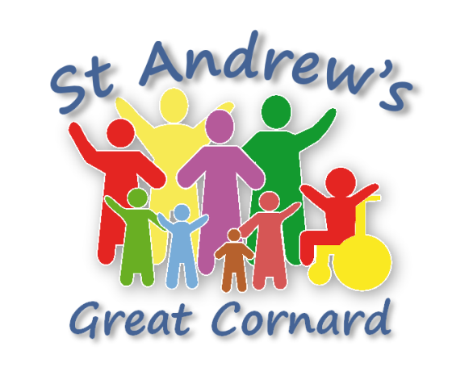

**Getting Married**

**at**

**St Andrew’s Church**

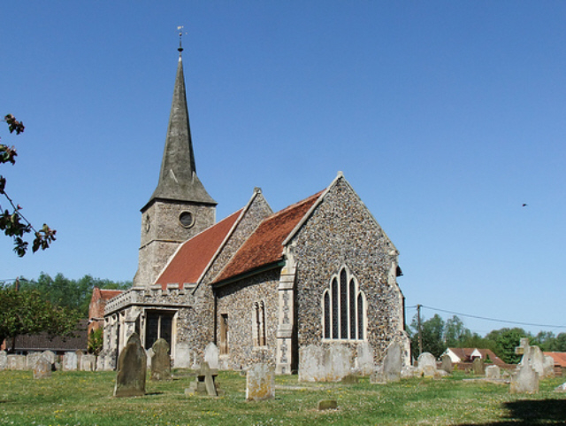

2023

**Congratulations!**

Here at St Andrew’s we believe that married is a live giving, joy bringing commitment which is God given and that God loves to bless.

We believe that a **church wedding will add a spiritual dimension to your marriage, seeking God’s blessing for your relationship sealed by the bonds of love you share. Your wedding is *Your Wedding* and we will seek to make it as personal, memorable, meaningful and beautiful as we can within a Church building which has been at the heart of this community for 700 years.**

We look forward to getting to know you both over the time between now and the big day and preparing for it. We also look forward to helping you prepare for every day of married life - and like to think that we can support you through all of life’s up and downs.

This little booklet serves as a very quick reference for you once you’ve met with one of our ministry team to book your wedding. It’s not meant as a definitive guide.

One of the best places to find out lots of really helpful information is the Church of England’s wedding site on the internet you can find this here:

[www.yourchurchwedding.org](http://www.yourchurchwedding.org)



“In Church it’s marriage in the eyes of God, which makes the commitment a bit stronger, I mean not in yourselves, it doesn’t change your feelings, but for some reason it puts that cloud over you– not a nasty cloud, a different cloud. It’s more than legal. It’s different - it’s proper.” –Quote from YourChurchWedding.org

**The practical bits**

**What’s the cost?**

The basic legal fee for getting married in any Church of England   
church is, (including reading your banns at St Andrews): **£567**

To that there are a couple of optional extras you can add:

**Organist** - your organist will play the hymns, the music for your **£100**  
entrance and exit from the church as well as playing during the   
signing of legal documents. *We can also run music from backing   
tracks, cds, laptop etc at no cost to you.*  
  
**Verger** **& Bells**-the verger at your service is there to take care of **£70**  
practical details, such as making sure that the heating is switched   
on in good time, that the church is clean and tidy, will assist any   
ushers in helping welcome family and friends into the church   
**and will ring the bells** at the end of the service.

**That’s a total of: ______£737**

If you live in another parish there will be an additional fee of **£54**  
payable to the church of that parish to read your Banns.

Fees are payable either by Cheque payable to: “St Andrews Great Cornard Fees” or preferably by bank transfer using the following details: account name: “St Andrews Great Cornard Fees”, Sort Code: 20-83-50 Acc no: 00588504 using your name as the reference.

These fees are correct for 2023, there will be a slight increase in 2025

**Who will take my service**

There are three members of clergy at St Andrew’s who can officiate at weddings – Rev’s Chris, Jennie and Rowland. We tend to share the services between ourselves depending on workload. On some occasions it may be necessary to ask someone else to step in if we’re not available – we would make sure that you have ample opportunity to meet with them before the big day.

**Photo’s and videos**

At St Andrews we have all the necessary licenses etc. to allow you to video the service. We do ask that any videographer’s and photographers are discreet however – it is your wedding that people have come to witness, not the photographer leaping around

**Can we choose our own readings/hymns/vows/etc**

You have a lot of choices to make – it is *YOUR* wedding after all.  
You have the choice of :

* **Hymns** – how many (1,2 or 3 usually) and even none if you wish
* **Music** – to come in to, to go out with and for while we sign the marriage registers – it can be traditional organ music or anything on CD (we do reserve the right of veto on inappropriate lyrics)
* **Readings** – You can choose the bible reading (we can help you choose by suggesting popular readings) and you can also have any other poems or prose which you would like to have. These can be read by friends and family.
* **Vows** – In addition to the formal vows which we must legally use, you are welcome to add your own promises to say to each other if you so wish. These are used in addition to, and separately from the formal wedding vows.

There are some great resources on www.yourchurchwedding.org which can really help you make some of these choices and your vicar will help you as well.

**Parking, Toilets and Children**

Parking can be difficult at St Andrew’s and we must rely on the goodwill of local residents for on street parking. We can usually cone off a couple of space outside the church for wedding cars or for those with mobility problems however.

We do have a toilet at St Andrews, though not in the building itself (we have a church “room” behind the church).

We love children at St Andrew’s and understand the difficulties of having them in church, which is perhaps an unfamiliar environment, to that end we have a play area at the back with toys and books for restless children.

**Contact**

If you have any questions at all at any time just drop Rev’s Rowland, Jennie or Chris a line.   
Rev Chris on 07716 848739, email: [revchrisramsey@standrews-gc.org.uk](mailto:revchrisramsey@standrews-gc.org.uk).   
Rev Jennie on 01787 375974, email [revjennieridley@standrews-gc.org.uk](mailto:revjennieridley@standrews-gc.org.uk)   
Rev Rowland on 07984 537063, email: [revrowlandbareham@standrews-gc.org.uk](mailto:revrowlandbareham@standrews-gc.org.uk)